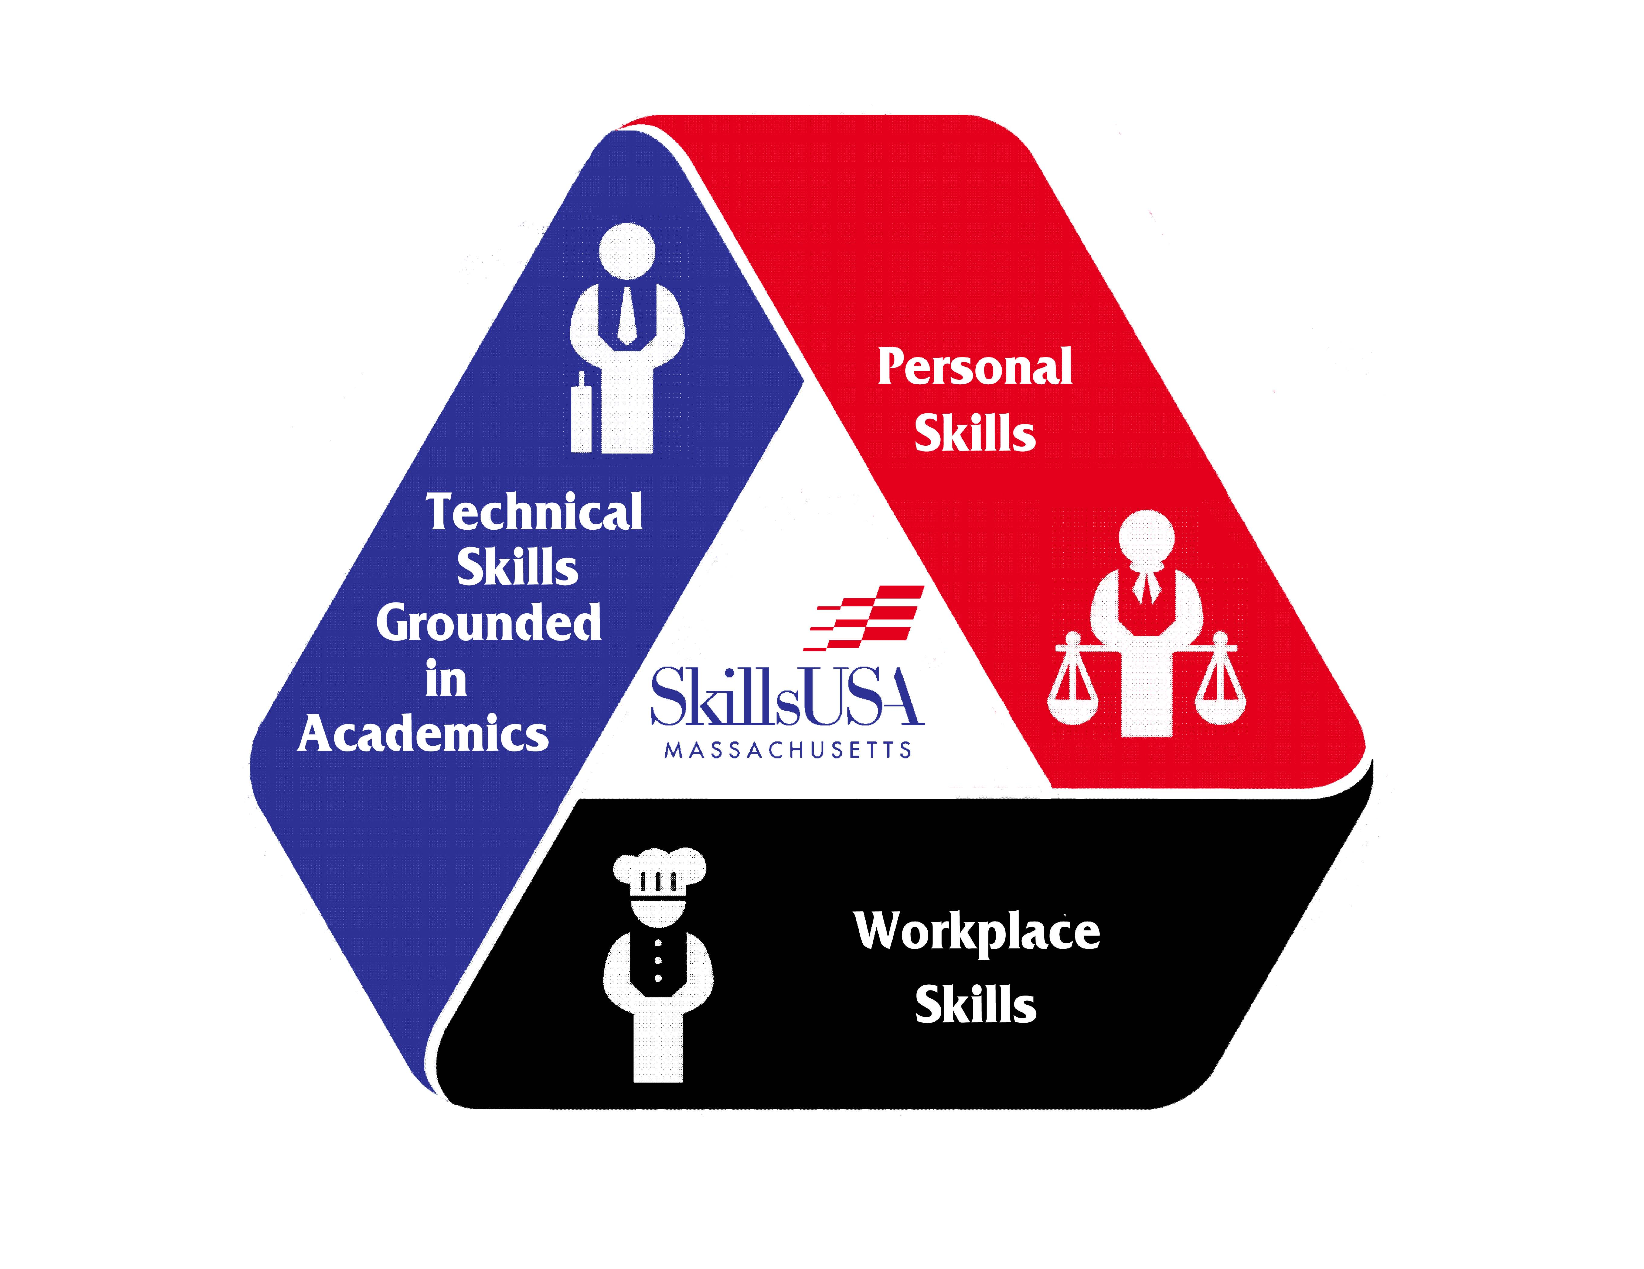
STATE OFFICER CANDIDATE
APPLICATION
Please Fill out and return to the state office.
First Name | Last Name:
Trade/ CTE Program: | School:
Address:
City: | Zip: |  | Home Phone:
Mobile Phone: | Email:
Advisor: | Advisor Email:
Superintendent: | Instructor:
Complete School Address:

Have you attended a SkillsUSA conference? If Yes, which?
Emergency Contact Information
Name |  | Relationship
Home Telephone |  | Work Phone
Name of Physician |  | Telephone
Medical Insurance Company
Policy Number |  | Membership Number

Officer Candidate - Local Confirmation
Officer Candidate
I understand the responsibilities of SkillsUSA state office and, if elected, I will attend all meetings and activities necessary for the successful fulfillment of my duties, including community service events and other weekend activities
Signature of Applicant
Parent/Guardian
I approve of my son/daughter/ward applying for a state SkillsUSA office and agree that he/she will be able to spend the time necessary to carry out the duties of the office. I also agree that my son/daughter/ward will have the necessary transportation to and from events and activities
Signature of Parent/Guardian
Chapter Advisor
I have reviewed this application with the candidate and I recommend him/her for state office. I am satisfied that the applicant understands the duties and responsibilities of state office. I also agree that the candidate will have the necessary transportation to and from events and activities
Signature of Chapter Advisor
Superintendent Director
Having reviewed this application with the candidate, I am familiar with the duties and responsibilities associated with state SkillsUSA office. I approve of this applicant running for state office and, if elected, agree that based on passing grades, he/she will be able to spend the time necessary and have the transportation and supervision required to carry on the duties of the office.
Signature of Superintendent Director
Please submit application and signature page along with the following FOUR letters of recommendations.
- Superintendent Director
- Section SkillsUSA Advisor or Employer
- Chapter SkillsUSA Advisor
- Chapter President
Please send all information to:
State Officer Candidate Application
SkillsUSA Massachusetts
250 Foundry Street
South Easton, MA 02375

