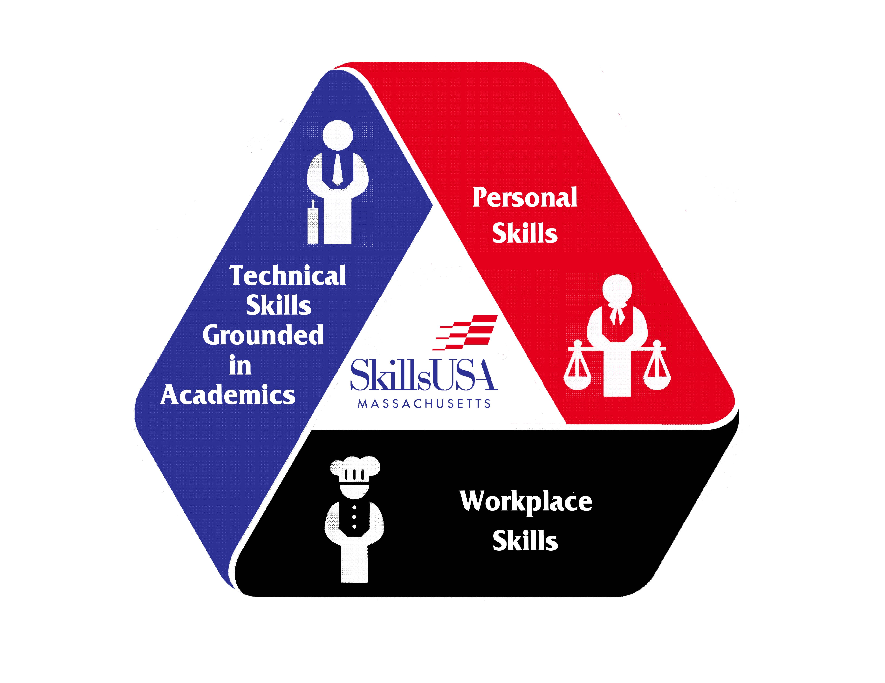
NATIONAL VOTING DELEGATE
APPLICATION
Please fill out and return to the state office.
First Name | Last Name:
Trade/ CTE Program: | School:
Address:
City: | Zip: | Home Phone:
Mobile Phone: | Email:
Advisor/Instructor: | School Telephone:
Advisor Email:
Complete School Address:

Have you attended a SkillsUSA conference? If Yes, which?
Application Deadline is April 1st.
- Provide two letters of recommendation: one from your SkillsUSA advisor and one from a school administrator
- Prepare and attach to the application a 300–500 word essay on why you would like to represent SkillsUSA Massachusetts on a national level serving as a national delegate.

Note: You and/or your SkillsUSA Chapter are responsible for all travel to and from meetings, and the National Conference. If your advisor is driving, he/she will not be participating in the meetings.
Please mail this application, postmarked by April 1st, to the address below to be accepted as a candidate for National Voting Delegate. An e-mail and formal letter will be issued in recognition of a complete application. Upon receiving confirmation applicants can begin preparations for election during the State Leadership and Skills Conference.
State Conference National Voting Delegate Application
c/o SkillsUSA Massachusetts
250 Foundry Street
South Easton, MA 02375
Or email: klopez@maskillsusa.org
For questions, please contact Kevin Lopez at 508-203-1207 or klopez@maskillsusa.org

Short Essay
Please write an essay of not less than 300 words and not more than 500 words describing why you would like to serve as a National Delegate for SkillsUSA Massachusetts. The 300–500 word essay must be typed in the space provided below or printed on a separate piece of paper from a word processor, and be attached to this application.
Selection Procedure
- Complete the application
- Provide two letters of recommendation: one from your SkillsUSA advisor and one from a school administrator
- Prepare and attach to the application a 300–500 word essay on why you would like to represent SkillsUSA Massachusetts on a national level serving as a national delegate
- Send your completed application with the essay attached to the SkillsUSA Massachusetts office no later than April 1st.
- Applications will be reviewed by SkillsUSA Massachusetts Personnel
- The number of delegates to be chosen may vary year-to-year and will depend on the number of slots available, after consideration for officers and officers elect.
- Announcement of National Delegates will be made at the State Leadership and Skills Conference.

Agreement
I hereby understand that if I should be selected to serve as a SkillsUSA Massachusetts National Voting Delegate that:
Your Name |  | Your Signature |  | Date
Parent/Guardian’s Name |  | Parent/Guardian’s Signature |  | Date
Chapter Advisor’s Name |  | Chapter Advisor’s Signature |  | Date
Shop Department Head’s Name |  | Shop Department Head’s Signature |  | Date
School Administrator’s Name |  | School Administrator’s Signature |  | Date
- I must complete the attached application with all information being complete and legible
- Provide one letter of recommendation from a SkillsUSA advisor and one from a school administrator
- Prepare and present a 300–500 word essay on why you would like to represent SkillsUSA Massachusetts on a National level serving as a delegate
- If selected I understand that I must attend a delegate meeting before the National Leadership and Skills Conference and that I must attend all delegate meetings during the National Leadership and Skills Conference and participate in all of the discussions
- I must have a grade point average of a “C” or better in each class academic and trade to fulfill the requirements of a delegate member.

My SkillsUSA chapter/school understands that they are responsible for and agree to pay all costs • associated with the National Leadership and Skills Conference (including registration fees, travel, lodging and food) for me as a national voting delegate.

