First Name | Last Name:
Trade/ CTE Program: | School:
Address:
City: | Zip: |  | Home Phone:
Mobile Phone: | Email:
Advisor/Instructor: | Advisor Instructor phone:
Advisor Email:
Complete School Address:

Submissions should be mail to:
State Pin Design Contest
c/o SkillsUSA Massachusetts
250 Foundry Street
South Easton, MA 02375
Applicant Signature |  | Advisor Signature
Date |  | Date
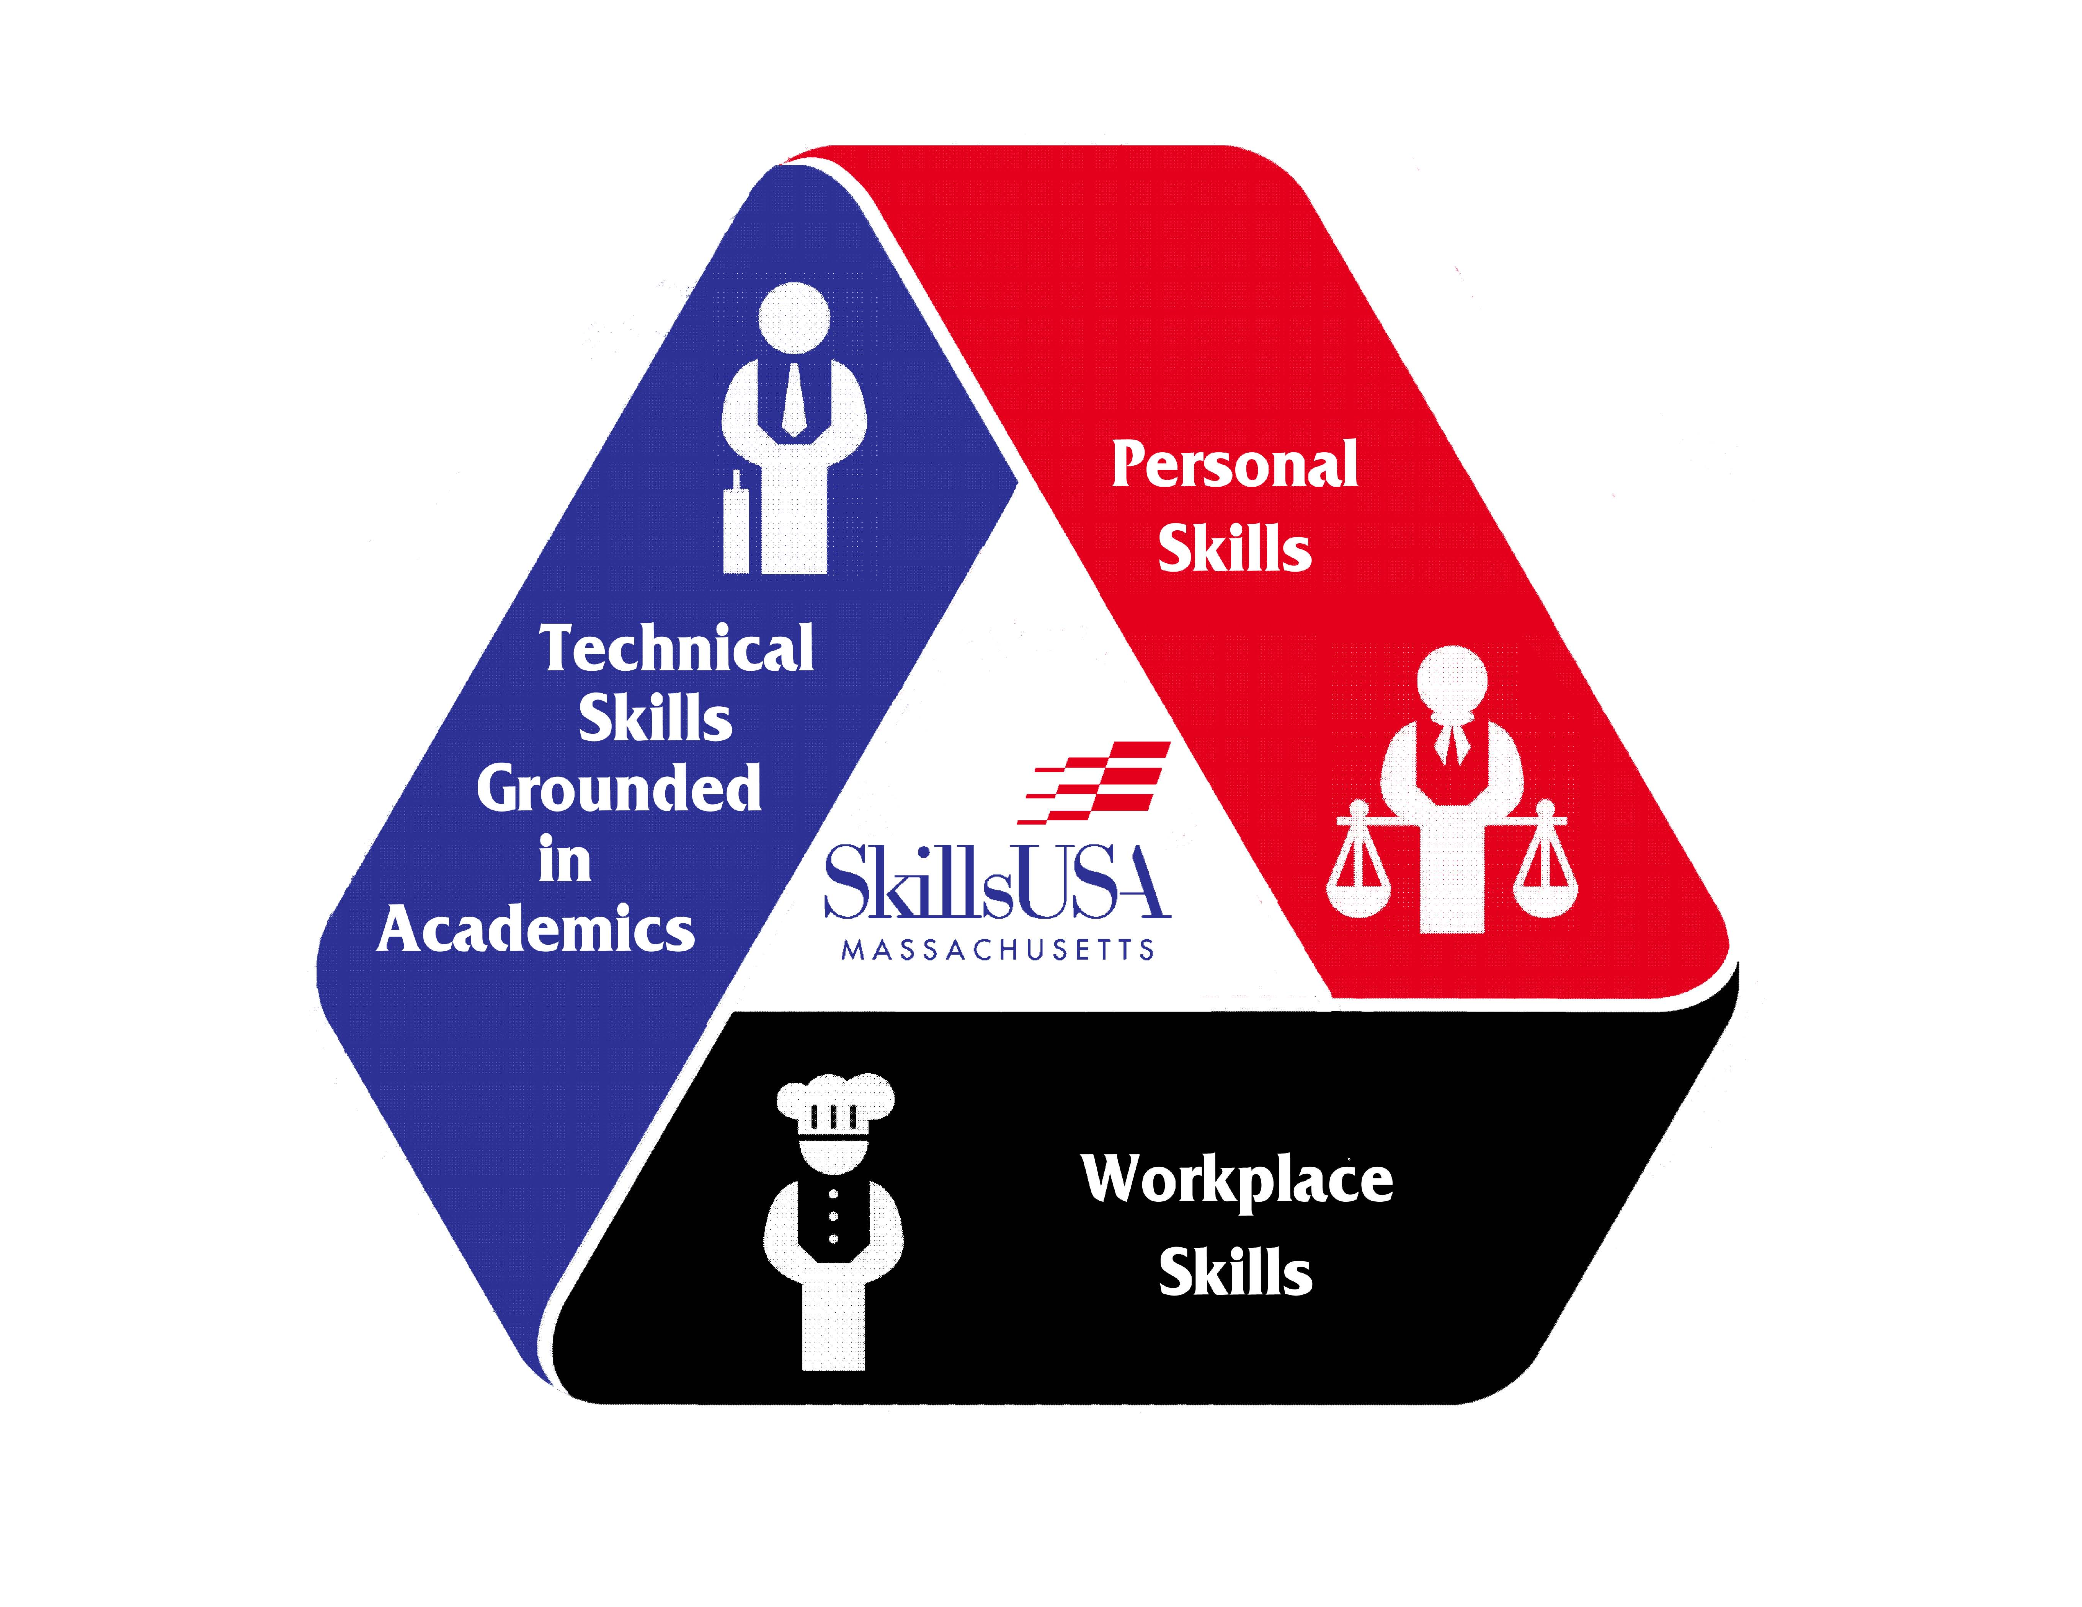
STATE PIN DESIGN CONTEST

Official State Trading Pin
The winning design in this category will be produced and used as the Official Massachusetts State Trading Pin at the annual National Leadership Conference and SkillsUSA Championships. The winner will receive a free trip to the National Leadership & SkillsUSA Championships in June. The winner is obligated to represent Massachusetts in the Pin-Design competition as a competitor at the national level.
In addition, the designer (with an illustration of the design) will be acknowledged in the Massachusetts SkillsUSA Championships Program.
Eligibility
This contest is open to all paid-in-full SkillsUSA Massachusetts members for the current academic school year, secondary and postsecondary.
Brand usage: The brands “SkillsUSA” and “SkillsUSA Massachusetts,” as well as the SkillsUSA and the SkillsUSA Massachusetts logos, must conform to the usage guidelines on pages 3–11 of the SkillsUSA Graphics Standard Manual located at www.skillsusa.org/downloads/PDF/Graphstandrds.pdf.
Incorrect usage of the brands and/or logos will result in disqualification of the entry.

Final Presentation: Two types of artwork—final size and the enlarged size need to be submitted for consideration.
- Actual final size of 1" to a max of 1.5"
- Enlarged size of 3”x 4.5” proportionate for a rectangle, 3" in circumference for a circle, 3" x 3" for a square

Submitting your design
Be sure to securely attach the registration form to the back of the design for consideration. In addition, the front-facing side of the design or board on which the design is attached to should not contain any elements that may identify the designer (this information should be on the registration form.) The deadline for the entry is December 31st postmarked.
Pin Requirements
- Comp large size: 3" x 4.5" proportionate • for a rectangle, 3" in circumference for circle, 3" x 3" for a square
- Final Size: 1", no larger than 1.5"
- Pin Color: Gold
- Color: Four spot colors may be used, black is considered a color
- Medium: computer generated or hand drawn
- Pin Shape: round, square or rectangle only. No custom shapes
Imagery: type, illustration, graphic representation or all mentioned.
Content:
SkillsUSA Massachusetts
Or
SkillsUSA
with drawing of the actual state

- You may add other content for clarification but it must be non-interfering.

Any questions contact the state office at (508) 230-1273 or kward@maskillsusa.org

